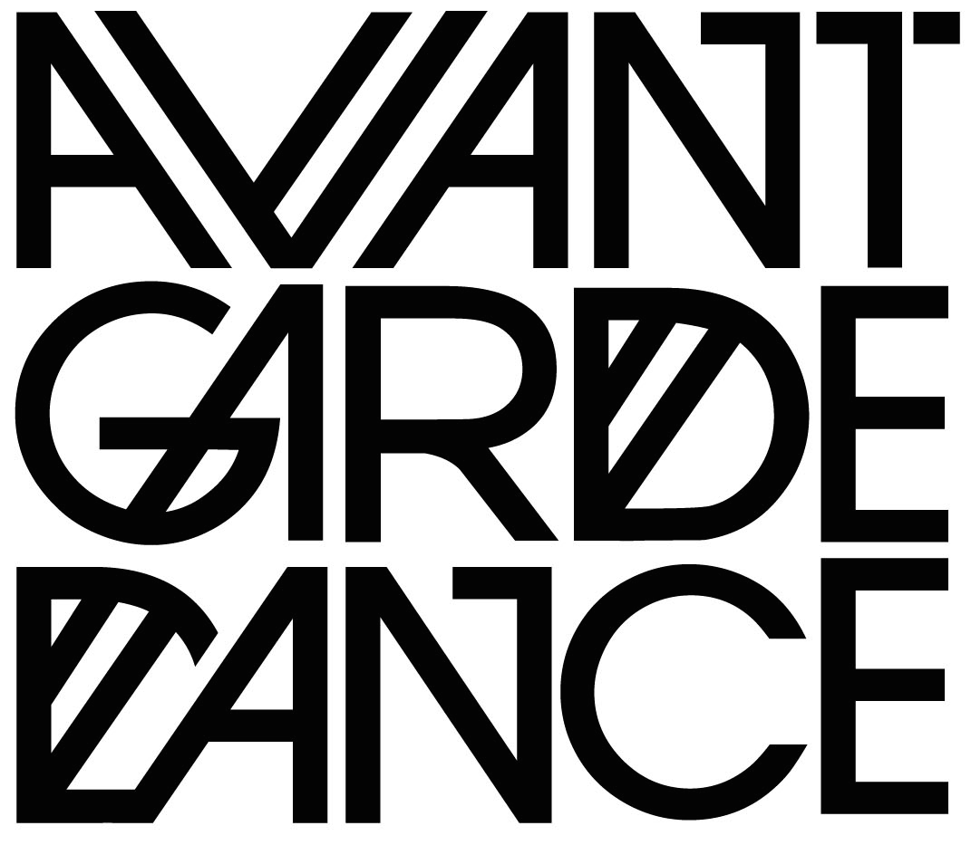
EQUAL OPPORTUNITIES MONITORING FORM
Thank you for applying for a position at Avant Garde Dance
Please complete and return this form with your application as a separate attachment. This information is confidential and will not be shared with the shortlisting panel.

DETAILS OF VACANCY
Post applied for
How did you hear about this vacancy? Please tick | E-newsletter Arts Orgs website  Avant Garde Website Producers network  Friend BAME Network  Colleague Dance Network  Online network Social media  ArtsJobs  Other (please state) ______________________

PRIVATE AND CONFIDENTIAL
All recruitment is based on an individual’s ability and job performance and excludes consideration of an applicant’s beliefs, political opinion, gender, race, sexuality, marital status, age, disability or a conviction or other information revealed. This is not a compulsory form however your information will give us a true picture of the effectiveness of our policy. Please complete and return this form with your application.

DETAILS OF VACANCY
Post applied for

EQUAL OPPORTUNITES MONITORING FORM
Information included on this form is used for Equal Opportunities monitoring purposes only and is not available to those shortlisting.
Date:

Personnel Details
Gender
Age (in years)

Cultural Diversity
Please state what you consider to be your cultural and ethnic origin |  | :  Rather not say

Disability
The term disability should be construed as including people with physical disabilities; people with learning difficulties; people with mental illness; those with sensory disabilities (such as blind or sight impaired); people with ‘hidden’ disabilities (such as epilepsy or those suffering from chest or heart conditions); and those with disabilities linked to aging
Do you consider yourself to have a disability? |  | Yes No Rather not say  (tick as applicable)

Sexual Orientation
Do you consider yourself to be LGBTQI | Yes No Rather not say  (tick as applicable)
If yes, please indicate how you describe yourself
Any other minority status?

